**HOW TO PREPARE YOUR PAPER? The title of PAPER, Times New Roman,   
Font SIZE 11 pt., Boldface, Capital Letters**

**1st Author's First and Last Name (no titles), 2nd Author's First and Last Name (no titles), ...**

***Abstract:*** *In a case of empirical (research paper) use the format of IMRAD structure (Introduction, Material and Methods, Results and Discussion). It should summarize the content of the paper below.*

***Key words:*** *keyword 1, keyword 2, keyword 3, ...* (no more than 5–7 keywords)

**1. Introduction**

Scope of the article is given – should not be more than 12 pages formatted according template (including list of references, images, tables and appendices). The body of the text shall be written in letters of Times New Roman, size 11 pt. Different styles are undesirable, use the normal template and also please avoid numbering of pages. The final version of the article ought to be formatted to the paragraphs. The Editorial Board reserves the right to refuse contributions.

**1.1 Subsections in Times New Roman, font size 11 pt., bold, no capital letters – example**

The file should be saved under the same name with the surname of first author and sent in a format with the extension .DOC or .DOCX (MS Office Word 2007 and upper versions). Before sending a fi le with the paper it is required to scan for possible infections or viruses. Authors are responsible for content and linguistic aspects of the contributions.

**1.2 Figures and tables – example**

Please, do not number pages. Images, graphs and tables should be numbered according to the example (*Figure 1: Preparatory exercise* [Times New Roman, font size 11 pt., italics, no capital and bold letters]) with the reference to it (them) in the text.

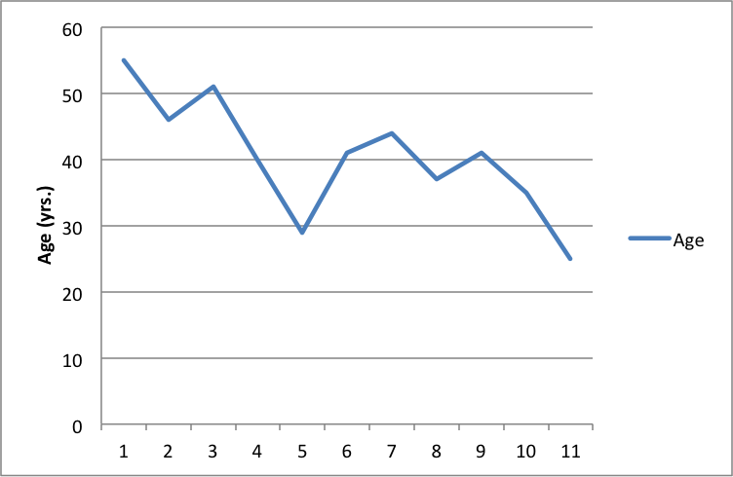

*Figure 1: Preparatory exercise*

**2. Recommendations**

It is highly recommended to spend the necessary time correcting the paper – every mistake will be multiplied. Posted papers unsuitable for printing will not be published! Ensure appropriate division and balance between the various parts of the contribution and aesthetic placement of pictures and diagrams as well as their quality. Terminological correctness and formality are required. Please note that publication of papers in the Journal will be free of charge.

Section headings should be numbered and written, as described in following manual: standard signs, symbols and abbreviations are to be used only. Monosyllabic preposition are ought not to figure at the end of the line, but at the beginning of the next line – they can be shifted using the “hard returns” CTRL + SHIFT + SPACE.

**Material and Methods**

Material and methods. Material and methods. Material and methods. Material and methods. Material and methods. Material and methods. Material and methods. Material and methods. Material and methods. Material and methods. Material and methods. Material and methods. Material and methods. Material and methods. Material and methods. Material and methods. Material and methods. Material and methods. Material and methods. Material and methods.

**Results**

Results. Results. Results. Results. Results. Results. Results. Results. Results. Results. Results. Results. Results. Results. Results. Results. Results. Results. Results. Results. Results. Results. Results. Results. Results. Results. Results. Results. Results. Results. Results. Results. Results. Results. Results. Results. Results. Results. Results. Results. Results. Results. Results. Results. Results. Results. Results. Results. Results. Results. Results. Results. Results. Results. Results.

**Discussion**

Discussion. Discussion. Discussion. Discussion. Discussion. Discussion. Discussion. Discussion. Discussion. Discussion. Discussion. Discussion. Discussion. Discussion. Discussion. Discussion. Discussion. Discussion. Discussion. Discussion. Discussion. Discussion. Discussion. Discussion. Discussion. Discussion. Discussion. Discussion. Discussion. Discussion. Discussion. Discussion. Discussion. Discussion. Discussion. Discussion. Discussion. Discussion. Discussion.

**Conclusion**

Conclusion. Conclusion. Conclusion. Conclusion. Conclusion. Conclusion. Conclusion. Conclusion. Conclusion. Conclusion. Conclusion. Conclusion. Conclusion. Conclusion. Conclusion. Conclusion. Conclusion. Conclusion. Conclusion. Conclusion. Conclusion. Conclusion. Conclusion. Conclusion. Conclusion. Conclusion. Conclusion. Conclusion. Conclusion. Conclusion. Conclusion. Conclusion. Conclusion. Conclusion. Conclusion. Conclusion. Conclusion. Conclusion. Conclusion.

**Acknowledgements (not obligatory)**

The article is dedicated to solved project / grant NAMED, No. ……. .

**References (alphabetical order)**

The list references to resources ought to follow these norms and directives: ČSN ISO 690 and ČSN ISO 690-2 or Publication Manual of the American Psychological Association (APA).

[1] Reference 1.

[2] Reference 2.

[3] ……………

[4] ……………

[5] ……………

[n] ……………

**In a case of Review Article, use this structure (example):**

* Introduction
* Aims
* Methods (Eligibility criteria, Sources and Search strategy, Study selection, Data analysis)
* Results and Discussion
* Conclusion
* Ethical aspects / Conflict of interest
* Acknowledgements – not obligatory
* References (alphabetical order)

**Contact Information**

**1st Author's First and Last Name (with titles), 2nd Author's First and Last Name (with titles), …**

Name of your University or Company

Address

ZIP Code, City

Country

1st Author's email; 2nd Author's email

**Full Paper Submission**

Please send us your paper in .DOC or .DOCX format only by email: [dan.bibaged@centrum.cz](mailto:dan.bibaged@centrum.cz). In the subject line of the email note: **JEP – contribution**. For more information see

<http://jep.upol.cz/JEP_Information%20for%20authors.pdf>.