Orientation and mobility of persons with visual impairment in the Czech Republic within the context of an evolving Europe

Veronika Růžičková*, Kateřina Stejskalová*
Libuše Ludíková*, Dita Finková*, Vojtech Regec*
Vít Voženílek**, Magdaléna Kozáková**, Zuzana Šťávová**,
Palacký University, Olomouc, Czech Republic
* Dept. of Special Pedagogy, Faculty of Education, Žižkovo nám. 1, 771 00 Olomouc
ludikova@pdfnw.upol.cz, ditafinkova@seznam.cz, veronika.ruzickova@gmail.com, katerina.stejskalova@gmail.com
** Dept. of Geoinformatics, Faculty of Science, tř. Svobody 26, 771 46 Olomouc, vit.vozenilek@upol.cz, magdalena.kozakova@seznam.cz, stavovaz@email.cz,

Introduction

Sensory deficit, or more precisely the loss of or significant in visual perception, significantly impacts all elements of an individual’s everyday life, while some elements can be severely limited as a result. One such element, which is determined by severe visual impairment in the most prominent manner, is the area of spatial orientation and mobility of persons with visual impairment.
For the visually impaired, independent orientation in space constitutes a key skill and is generally considered to be an inherent part of literacy in such persons. Mastering it is a prerequisite of self-sufficiency, independence, and personal freedom.
The ability of independent, safe and effective orientation in space is a complex product of the motor, sensory and cognitive abilities. For a person with visual impairment, performance in this area has a direct impact on the quality of his/her life and is reflected in the level of his/her socialization, or more precisely his/her social integration. In this context, and in concurrence with tremendous advancements in information and communication technologies, the concept of multi-sensorial approach is currently preferred for spatial orientation of persons with visual impairment. This approach suggests the need for complex utilisation of all compensatory mechanisms for effective orientation and for building a solid perception about space, not only through hearing but also via the tactile path. At the same time, for an individual with visual impairment it opens the possibility of choosing a subjectively optimum system of navigation.
Despite the up-to-date modern trends in the area of spatial orientation and navigation, for example by means of GPS, tactile information in the form of tactile maps and plans still maintain its irreplaceable place. Through orientation in microspace, a more complex cognition of the macrospace is subsequently achieved. Naturally, there are factors determining the quality of information provided through the tactile path, such as individual dispositions for tactile differentiation and analytically-synthetic activity, previous visual experience and the level of visual imagination; nevertheless, developing and improving the natural prerequisites for tactile perception will project not only in the area monitored by us, the area of spatial orientation, but in a broader context will support the field of Braille reading and typhlographics (graphic embossed images for persons with visual impairment)
Optimizing cartographic tactile images from the perspective of tactile perception physiology is then an essential prerequisite for their effective utilisation by persons with visual impairment. In an ideal case, the resulting effect should also reflect in the integration of this area as a common part of spatial orientation and its teaching.

Prerequisites of successful mastering of mobility by persons with visual impairment

For persons with visual impairment, one of the first important steps on the way to spatial cognition of the space around us is most certainly mediation by another person’s perceptions. However, listening and appreciation of the basic principles, rules and regularities should, after some time, be replaced by own initiative pursuant to which a person would manage to orientate due to his/her own skills.

Learning about the microspace
One of the options of macrospace cognition, although obviously not the only one, is learning how to orientate in the microspace. For better orientation on a surface, or in otherwise closely defined area, it is important to know how to use the touch sensation. Touch is one of the paramount compensatory factors, and a correct warm-up is one of the main prerequisites of its correct use.
Touch, according to Litvak (1979), may be divided to:
Passive touch.
Active touch (haptics).
Instrumental touch.

For working in microspace and distinguishing the basic, fine and significant nuances, mainly active touch is used in the form of intentional feeling. The aforementioned active touch is naturally also utilised in reading tactile images, maps and other graphic images. “In reading embossed images, four techniques of feeling are mostly used:
- orientation hand movement with fingers slightly spread (going across the entire drawing in a snake-like manner from top to bottom, in a spiral movement, and around its periphery or its central part): enables to find an image on area of the drawing and stipulate its borders,
- movement along the outlines (with the index finger along the lines: ascertains arrangement of details and its location),
- parallel movement of two fingers:
the thumb remains at the initial point, the index or other finger follows the line to its end; suitable for estimating the length and direction of a line from the initial point, differentiating a circle from an ellipse;
firm position of the thumb – index finger angle, and their movement to the right or left; used for distinguishing a square, a rectangle and a triangle;
diverting the thumb and the index finger from the centre of the line to the right and left, their subsequent vertical parallel running and then bringing together; suitable for identifying parallel and intersecting lines;
parallel running of the thumb and the index finger; used for stipulating an angle by diverting fingers from the initial point, etc.;
- parallel movement of both hands; broadening the tactile area of the hand is achieved, faster viewing of even larger size images;
- utilising all fingers; enables to record a larger number of orientation points, guide lines and details, while the activity of one hand and one finger (or two fingers, while using the opposition of a thumb) is usually dominant).” (Keblová, 1999, page 14-15)

Spatial orientation skills development during the process of education

The basic skills, acquired by a child within a family may and must be further developed within the preschool and subsequently the school educational process. As part of school attendance, competences development is anchored by means of a general educational program for primary schools, not only within the subject of spatial orientation and mobility of persons with visual impairment but also in visual arts education, physical education and geography.

Spatial orientation and mobility development

The deficit in the area of spatial orientation and mobility in persons with visual impairment is known to the laics as well as the experts, who have been trying to reduce it or eliminate it altogether for a number of years. In the Czech Republic, a methodology has been worked out for each group of persons with visual impairment on how to develop this area.

In children, who are blind since birth or whose impairment was acquired at early age, the basic techniques of walking without a cane, especially safe posture, trailing, the fundamentals of walking with a guide, possibly also strengthening the stability, etc., are developed within the family environment and subsequently, in the kindergarten.

At primary schools, spatial orientation was anchored as an independent subject for blind pupils and pupils with severe visual debility. The methodology in this subject results from abilities that are physiologically given to pupils of respective age. The teaching subject is divided to 4 basic stages:
- 1. Grade 1 - 3: pupils adopt and perfect the basic techniques of walking without a cane. Once this stage has been mastered, stage two follows, which is allocated one lesson per week, just like this stage.
- 2. Grade 4 - 5: given their age, pupils already have prerequisites of controlling the white cane and therefore, they train on its use. Training is first conducted in a building and subsequently, the mastering of movement in such “safe environment” is then moved outside.
- 3. Grade 6 - 7: owing to training for more difficult paths (paths with obstructions, walking the streets, travelling on public transport, etc.), teaching is allocated two lessons every 14 days.
- 4. Grade 8 - 9: relatively trouble-free control of the white cane is expected for pupils, walking longer routes with seeking targets is trained. The allocation is also two lessons every 14 days.

In order to be able to stipulate allocation and to provide teaching, there is a teacher with spatial orientation instructor certification at all primary schools for pupils with visual impairment. The special education centre should ensure the teaching of integrated pupils.

The basic training of spatial orientation and mobility for persons, who have lost the possibility of acquiring information through sight after completing primary school attendance, is provided either by “Typhlo-service” (a non-government organization for persons with visual impairment over the age of 15), “Dědina” – “Village” (a non-government physiotherapy and retraining centre in Prague) or other non-state organizations that employ certified instructors. It is the decision of an individual with such impairment as to which of the above stated possibilities will he/she opt for. The methodology of all instructors results from equal standards of their education, and it should therefore not differ in significant requisites. Generally, it can be stated that the methodology of educating adults is similar to the methodology of educating pupils, the only difference being that it is significantly faster.

In the event of a situation when a grown individual needs to learn a particular route, he/she can contact any of the subjects that, according to legislation, are entitled to provide this service (see below).

Spatial orientation and mobility (O&M) in the European context

In the context of the change in approach to persons with impairment on a scale of the entire society of 1960’s, the area of spatial orientation of persons with visual impairment also developed. During the past forty years there has been a worldwide developmental trend, however rather uneven, of professional courses for instructors of O&M for the visually impaired. The O&M techniques were created in the U.S.A. and soon adopted by experts in Britain as well as in other countries.
In June 1950, an American office of work physiotherapy stipulated educating specialists on O&M as one of its priorities in the area of physiotherapy. The American Foundation for the Blind convened a conference, introducing the first step towards professionally anchoring the O&M instructor position and the requirements for its minimum education and work principles. The first grant stipulated for the educational program for O&M instructor’s development was obtained by the Boston College in 1960.
In Great Britain, the O&M techniques were officially accepted subsequent to a series of studies conducted between 1964 and 1966 for the purpose of ascertaining its efficiency. The experiences from the U.S.A. were resulted in The Birmingham Royal Institute for the Blind founding the National Mobility Centre, which during the following twenty years trained over 400 O&M instructors from Germany, Denmark, Holland, Belgium, Australia, New Zealand, India and other countries.
In Sweden, O&M training was introduced before 1952, after the first O&M instructor was trained in Hines VA Hospital in the U.S.A. Currently, all Swedish O&M instructors are trained within the Stockholm Institute of Special Education. There are currently (1997) only about 75 O&M instructors there.
In 1952 Netherland also started practicing O&M, although on a very small scale with the support of the Royal Institute for the Blind Hulzon-Bussuem. Based on the conducted studies, the Dutch invited an O&M instructor from the U.S.A. for a period of six months for the purpose of creating and stipulating the essentials of a program for training instructors. In 1990 a national program for educating O&M instructors was introduced in the Netherlands. Approximately 20 specialists are trained every year. The module “Spatial orientation and mobility” is also part of the education for special schools teachers.
Denmark commenced its first training courses for O&M instructors in 1970, when the first instructor was trained in Birmingham. Instructors from Iceland, Norway, Ireland, Greece, Turkey and Finland also underwent the Danish courses. Finland came up with an idea of introducing O&M courses as part of the curriculum for individuals with visual impairment. The Finish Central Federation of the Handicapped established a one-year course for O&M instructors.
In Norway, O&M training was started at the Huseby School for the Blind in 1964, thanks to a physical education teacher who underwent training in Sweden and at the Western Michigan University. In 1985 an O&M university educational program was founded here. The platform of members of the National Norwegian Association of O&M instructors is currently formed of about 50 instructors.
In France a training centre (French Mobility Center at Marly le Roi, later renamed to Association pour les Personnes Aveugles ou Malvoyants) for O&M instructors was founded in 1980; instructors from Switzerland and Spain graduated from it.
O&M training in Germany commenced in 1972 after two instructors passed a course in Britain. Soon after the O&M courses were introduced in the School for Blind in Marburg. In the 1970’s a Mobility Centre for training instructors was established here. In 1979, in Hamburg, an Institute for Rehabilitation and Integration of the Sight Impaired (IRIS) was founded, educating O&M instructors and physiotherapy workers for the entire Europe, especially for the German speaking regions.
In Spain, the national organization for the blind (Organización Nacional de Ciegos Espaňoles) initiated O&M courses in the 1980’s. Part of the course, led by trained instructors from Europe, was focused on practical skills; other parts contributed to the theoretical fundamentals of O&M, which was shielded by professors from various Spanish universities.
Two instructors, who obtained their training in IRIS, were present at the outset of the O&M courses in Italy in 1989 and 1990. The first course was established with the support of the National Union of the Blind and was conducted in Milan, followed by another course in Rome. In 1991, there were 13 qualified O&M instructors in Italy.
The first course for O&M instructors in Poland was founded in 1989; a similar situation was also characteristic for Hungary.
The above information clearly shows the interest of experts and laics in this area, which in a significant manner determines social integration of an individual with visual impairment and his/her quality of life. The International Mobility Conference, which is organised on an international basis, serves as proof of the interest and the key position of this issue.

The possibilities of spatial orientation and mobility instructors training in the Czech Republic

As it was stated above, relatively slow start, a composed process and in the majority of cases a positive successful conclusion are characteristic for teaching spatial orientation and mobility of persons with visual impairment. Just like the course of teaching O&M for the visually impaired, also the training of spatial orientation instructors and teachers in the Czech Republic, or more precisely in Czechoslovakia, commenced relatively late as compared to other states – at the break of the 1970’s and the 1990’s. Amongst the first pioneers and the propagators of O&M training not only for persons with visual impairment, but also for their instructors, was prof. Jesenský, as well as the creator of methodology for spatial orientation instructors, or primary school pupils, Mgr. Pavel Wiener. Gradual development of the methodology led to the emergence of several centres and means of obtaining a licence for becoming a qualified instructor. We should mention the most significant ones here:

- Till the end of 2008, there was an Institute of Physiotherapy for persons with visual impairment, which was managed by its Director, Pavel Wiener. This institute operated at the Charles University, the Faculty of Arts, and during its more than ten year history trained tens of instructors. The courses were yearlong and instructors not only learned how to plan routes and guide their clients to become independent, but also in the beginning how to master the white cane. This course was stipulated for specialists already working with persons with visual impairment, and it was conducted in the form of university education seminars, which took place once every fortnight on Thursdays and Fridays. Subsequent to passing the course, a successful graduate obtained a three-year licence which was/is then renewed every three years and thus maintained the quality and assurance of further training of instructors.
- Another course, stipulated not only for the general professional public but also for laics, is the course organised by PhDr. Trhlík from the Special Education Centre. It is a three-day course, usually conducted from Friday to Sunday. Based on passing this seminar, led on very intensive basis, the graduate obtains a lifelong certificate for performing the work of an O&M instructor for persons with visual impairment.
- A gap in the market, which occurred due to the Institute of Physiotherapy for persons with visual impairment closing down (see above), is partially filled by the Brno Typhlo-centre (an organisation providing services / physiotherapy of 2nd degree to persons with visual impairment over 15 years of age), which runs courses of the same methodology and the same scope as the first mentioned organisation.
- The last option of acquiring a lifelong certificate as an O&M instructor for persons with visual impairment is becoming an employee at the Typhlo-service (an organisation providing services / physiotherapy of 1st degree to persons with visual impairment over 15 years of age). This organisation runs courses for its employees. The given courses are divided into two parts – theoretical acquaintance with the methodology and forms of work and subsequently acquiring practical experience under the supervision of experienced instructors.

In the previous lines, we summed up the basic and the most prevalent possibilities of acquiring certification as an instructor of spatial orientation for persons with visual impairment. The stated certificate must also be held by every primary school teacher, who teaches the subject of spatial orientation to pupils with blindness or severe visual debility (see above).

The subject Spatial orientation and mobility of the visually impaired had its curriculum approved in 1998, and it results from experience with training spatial orientation in Czechoslovakia and subsequently, also in the independent Czech Republic during the past twenty years. The training itself is then elaborated into four phases, always with respect for the abilities and requirements of a pupil of the given age. A pupil with severe visual impairment should, within his/her school attendance, must acquire the skills to such degree so as to be absolutely independent and self-contained as far as orientation is concerned.

The parameters of embossed images, used for creating tactile maps
Within each of the mentioned teaching subjects, including spatial orientation and mobility, pupils’ other required skills and abilities are also developed for the purpose of which the teacher has a number of aids and instruments. Probably the most suitable for developing touch, imagination and subsequently also spatial orientation are maps. The issue of how embossed images and maps should look like is being addressed by a number of Czech as well as foreign experts (Guillie, Kunz, Bürklen, Wanecek, Hebold, Heller, Sverlov, Jesenský, Janková) for some time now. In the Czech Republic, Prof. Jesenský has been dealing with the standards for plastic figuration for the longest period of time, Petr Červenka (1999, p. 11) results from his work and states that “for embossed drawing, low relief and an embossed model, the following values can be recommended:
-embossed drawing: the baseline width (according to technology), minimum distance of two lines (3 – 5 mm, preferably 5 mm),
-a low relief: minimum distance of two edges (3 – 5 mm),
-embossed model: minimum width of communication (20mm), minimum distance of two edges (3 – 5 mm)”.

It is apparent that mere learning of how to distinguish microspace and therewith the linked distinguishing of embossed lines cannot lead to perfect orientation during walk and movement in open space or in buildings. However, it is absolutely certain that orientation in tactile maps and plans may further contribute to the images being formed to be more precise, certain and also more corresponding to the actual surroundings.

Project “Perception of Geospace by means of modern tactile maps”

In the following lines, we would like to introduce the Czech Science Foundation project (Perception of Geospace by means of modern tactile maps), which is based on the given characteristics.

The project is planned for the period of 2008-2010. Two teams were joined for the purpose of executing this project. One team is from the Faculty of Natural Sciences at the Palacký University of Olomouc, the Geoinformatics Department, led by Prof. Voženílek. The second team operates at the Faculty of Education of the same university, at the Department of Special Education, and is led by Prof. Ludíková. The liaison of the two different groups provides an ideal background for activities within this project.

The idea for this project originated from the needs analysis of persons with visual impairment, mainly from the absence of suitable teaching material for teaching spatial orientation and mobility of persons with visual impairment, which is essential in order for such persons to be able to lead common and independent lives. Another stimulus, which instigated the origin of this project, was insufficient teaching material for pupils with visual impairment and their teachers.

In the Czech Republic, the teachers of blind pupils and pupils with visual debility currently only have two options of geospace perception. Pressed foils and plastic embossed maps (thermo-vacuum foils, thermoactive foaming substances) are used, or the teachers even make such teaching maps themselves, usually by layering of individual surfaces on top of one another. Another example is also a modification of the plastic embossed maps by marking line elements, and sticking descriptions in Braille to the maps. Making of such maps is very demanding and the reduced availability also complicates teaching in the given area.

Today, when various technologies are developing, plastic maps of this type can from the worldwide standards perspective no longer be perceived as sufficient.

During foreign markets research and investigation of experience with tactile maps in other countries apart from the Czech Republic, we came to understand that there are currently many possibilities of providing better exploration and cognition of space to persons with visual impairment.

During the past decade, it was especially the psychological aspects of spatial image and research of predispositions for tactile perception that was accentuated in the area of tactile maps. The primary interest of geography in specific aspects of cartographic images for socio-economically and ethnically handicapped groups was gradually transferred to the issue of perceiving such images by persons with visual impairment. Preponderance of research was built on laboratory basis and application of their results to natural environment was minimal. However, these works confirmed the hypothesis that blind persons have the same cognitive spatial abilities as intact individuals, the only difference being that their configuration knowledge is less complex due to reduced access to information and insufficient previous experience. Results of the studies state that using tactile mapping may significantly improve cognitive maps of persons with visual impairment, and thus improve awareness about space and the surrounding environment, as well as improve spatial orientation (Perkins, 2002).
In 1994 the Pasadena City College published results of examination, focused on developing spatial orientation of their students within the campus area aided by effective tactile plans. With the aim of providing plans that would have the best possible quality and optimal recognition by touch, the research focused on the efficiency of embossed images from the perspective of their tactile differentiation. The desired outcomes were conventionalized graphic images of the campus that would provide its students with sufficient and precise information, utilisable within spatial orientation. (Clark, D., Clark, J., 1994)

As for the time factor of the project executed by us, it has been divided to three years; while this year sample 3D maps are already being prepared. The new tactile maps are created according to the needs analysis of blind persons and persons with a visual debility. During production, all general principles of processing tactile maps have been followed, i.e. overall slipperiness of the surface, no health hazard, washability, etc.

The project already commenced last year comprising of a sample card of patterns, colours and marks allowed us to begin testing at primary and secondary schools. This year, the testing continued at more primary schools and also at organisations for adults with visual impairment – in Typhlo-centres. Based on these tests, which have not yet been completed, the results analysis will be created and presented at the conference for the purpose of which this textbook is being published. The first of the planned modern tactile maps will be created on the basis of the aforesaid analysis.

The expected outcomes of the project are thus for example the following outputs:
- instructions for creating a modern tactile map composition,
- a catalogue of tactile maps’ geovisualisation methods,
- creating three types of modern tactile maps,
- inclusion of a new tool into the education and physiotherapy process for blind persons and persons with visual debility,
- etc.

Presentation of project results to date
The project is almost two-thirds complete, and the first test has been done – testing of legend and the sample card (see Fig. no. 1) of material for tactile maps of type A, B, C. Testing was carried out in establishments for pupils as well as for adults:
- Grammar school and Secondary vocational school Prague – Nové Butovice,
- Primary and secondary school at Kamenomlýnská street,
- Typhlo-centre Olomouc,
- Typhlo-centre Karviná.
Fig. no. 1 – Sample card
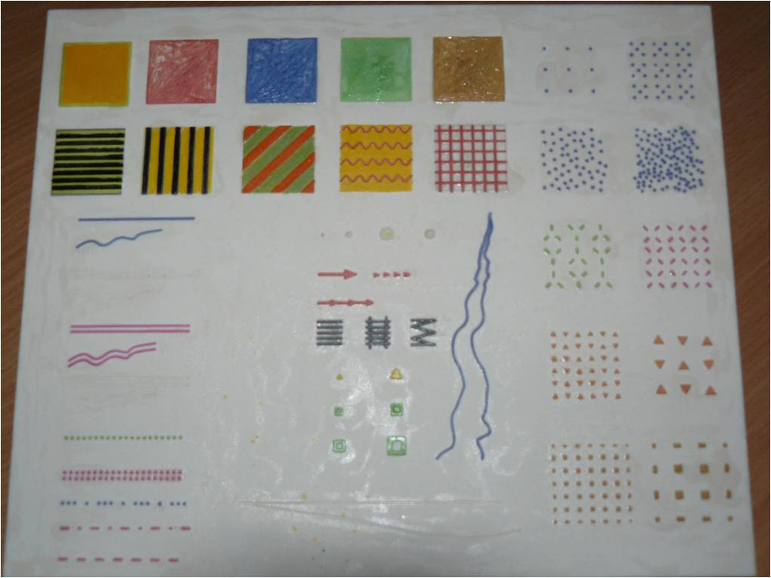

On the basis of testing, responses by 51 respondents were acquired (11 adults and 40 primary and secondary school pupils). Of these, 31 were blind (7 adults and 24 pupils) and 20 had severe visual debility (4 adults and 16 pupils). We were surprised to find that the responses of primary and secondary school pupils usually corresponded with the statements of adults. It means that the touch of primary school pupils from class 6 onwards is developed in a similar manner as that of adults. Results are stated in tables below.

For the purpose of testing, the sample card was divided to sections A – F (see Fig. no. 2).

Fig. no. 2 – Sample card with description
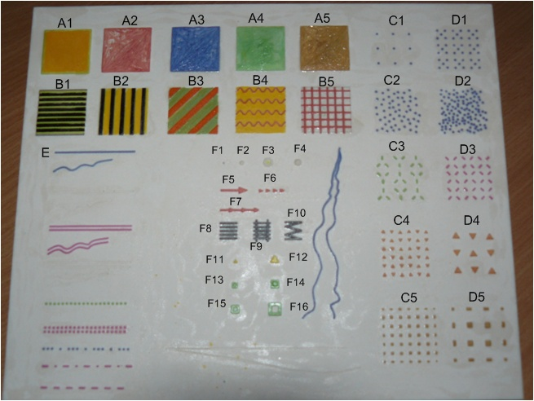

Table no. 1 – Conforming values ascertained in a group of blind respondents
parameter | percentage reference | number of respondents
A1 | 6.06% | 2
A2 | 3.03% | 1
A3 | 3.03% | 1
A4 | 3.03% | 1
A5 | 3.03% | 1
B1 | 12.12% | 4
B2 | 21.21% | 7
B3 | 12.12% | 4
B4 | 9.09% | 3
B5 | 9.09% | 3
C2 | 3.03% | 1
D3 | 3.03% | 1
D1 | 3.03% | 1
E6 | 3.03% | 1
F7 | 3,03% | 1
F8 (crossing) | 15.15% | 5
F9 (tracks) | 15.15% | 5
F10 | 3.03% | 1

Table no. 2 – Non-conforming values ascertained in blind respondents
parameter | percentage reference | number of respondents
A4 | 3.03% | 1
B4 | 3.03% | 1
E2 (neg. relief) | 24.24% | 8
E4(neg. relief) | 24.24% | 8
E6 | 3.03% | 1
A2 - A3 (surface) | 24.24% | 8
A3 - A5 | 3.03% | 1
A3 - C2 | 3.03% | 1
B1 - B2 | 3.03% | 1
B2 - B3 | 3.03% | 1
B2 - B5 | 3.03% | 1
C1 - C3 | 3.03% | 1
C2 - C3 | 3.03% | 1
C2 - C4 | 3.03% | 1
C2 - D1 | 3.03% | 1
C3 - C5 | 3.03% | 1
C4 - C5 | 6.06% | 2
D2 - C2 | 3.03% | 1
D3 - C2 | 3.03% | 1
D3 - C3 | 3.03% | 1
D3 - C4 | 12.12% | 4
D3 - C5 | 3.03% | 1
D3 - D1 | 6.06% | 2
D4 - D5 | 9.09% | 3
E5 - E8 | 6.06% | 2
E5 - E9 | 3.03% | 1
E7 - E8 | 39.39% | 11
E7 - E9 | 27.27% | 9
E8 - E9 | 33.33% | 11
F1 - F2 | 6.06% | 2
F5 | 3.03% | 1
F6 (small arrows one after another) | 21.21% | 7
F13 | 3.03% | 1
F7 - E9 | 3.03% | 1
F8 - F9 | 6.06% | 2
F11 | 6.06% | 2
F11 - F12 | 6.06% | 2
F11 - F13 (squares) | 30.30% | 10
F12 - F14 | 3.03% | 1
F13 - F15 (squares) | 15.15% | 5
F13 - F14 | 9.09% | 3
F14 - F16 | 6.06% | 2
F15 | 3.03% | 1
F15 - F16 | 6.06% | 2

Table no. 3 – Conforming values ascertained in respondents with visual debility
parameter | percentage reference | number of respondents
A1 | 5.88% | 1
A2 | 11.76% | 2
A3 | 5.88% | 1
A4 | 17.65% | 3
A5 | 5.88% | 1
B1 | 17.65% | 3
B2 | 35.29% | 6
B3 | 11.76% | 2
C4 | 5.88% | 1
C5 | 5.88% | 1
D2 | 5.88% | 1
D3 | 5.88% | 1
D4 | 5.88% | 1
E3 | 23.53% | 4
E6 | 5.88% | 1
F5 | 11.76% | 2
F6 | 11.76% | 2
F7 | 11.76% | 2
F13 | 5.88% | 1

Table no. 4 – Non-conforming values ascertained in respondents with visual debility
parameter | percentage reference | number of respondents
B1 | 11.76% | 2
B3 | 5.88% | 1
B4 | 5.88% | 1
A1 - A5 (colour) | 17.65% | 3
A2 - A5 | 5.88% | 1
C4 - C5 (colour, shape, size) | 35.29% | 6
D3 – C3 | 5.88% | 1
D3 - C4 | 5.88% | 1
D4 - D5 | 5.88% | 1
F6 | 5.88% | 1
E7 - E8 | 11.76% | 2
F1, F2 | 5.88% | 1
F11 - F12 | 5.88% | 1
F13 - F15 | 5.88% | 1
F13 - F14 | 5.88% | 1
F15 - F16 | 5.88% | 1

The following facts result from our research, which to a greater extent, were processed from the above stated tables:
- the need to intensify colours (ideal colour combination was orange with green and the most pronounced was pink)
- do not use chain-dotted, dotted and dashed lines together on one map
- do not use structures marked as D1, C2 and D3 furthermore, C4, C5 and also C4 and D3, at the same time
- arrows may only be used in the F5 format, in F7 format only as a line (direction of the arrow is not clear)
- marks used for F11 and F13 are not distinguishable, therefore the larger option F12 and F14 should be used.

Our initial results are to a certain degree supported by the above stated research of the Pasadena City College, pointing towards simpler images without excessive details. Simple or double lines, as well as simple chain-dotted lines, were assessed as effective; on the contrary the dotted lines, cross-hatched lines and patterned lines were assessed as ineffective. Simple geometric shapes (a circle, a square, a triangle) presented optimum symbolic images. (Clark, D., Clark, J., 1994)

Owing to the fact that we are presenting this contribution just before the tests of tactile maps type A are to be performed, we will present more detailed results directly at the conference.

Conclusion

It is clear that spatial orientation and mobility development is impacted by several factors. We believe that elaboration and easy use of these tactile maps could be one such factor. We are convinced that the utility of new tactile maps will be very extensive, commencing from its use in teaching at primary and secondary schools, to their utilisation by Typhlo-centres and Typhlo-services employees when working with adults with severe visual impairments.
Literature used

BLASCH, B. B., WIENER, W. R. Foundations of Orientation and Mobility. 2. edition. New York : American Foundation for the Blind, 1997. ISBN 0891289461, 9780891289463
CLARK, D., CLARK, J. Creating Tactile Maps for the Blind Using a GIS. American Congress on Surveying and Mapping [online]. 1994 [cit. 2009-03-08]. Dostupný z WWW: < http://hdl.handle.net/2014/32438>.
ČERVENKA, P. Mapy a orientační plány pro zrakově postižené. Praha: AULA, 1999. ISBN 80 – 902667-4-6.
FINKOVÁ, D.; LUDÍKOVÁ, L.; RŮŽIČKOVÁ, V. Speciální pedagogika osob se zrakovým postižením. Olomouc: UP, 2007. ISBN 978-80-244-1857-5.
GOLLEDGE, Reginald G. Geography and the disabled : A survey with special reference to vision impaired and blind populations. Transactions of the Institute of British Geographes [online]. 1993, vol. 18, no. 1 [cit. 2009-03-08], s. 63. Dostupný z WWW: <http://www.jstor.org/stable/623069?cookieSet=1>.
JESENSKÝ, J. Tyflografické výzkumy a studie. Praha: SI, 1983.
KEBLOVÁ, A. Hmat u zrakově postižených. Praha: Septima, 1999. ISBN 80 – 7216-085-0
LITVAK, A. G. Nástin psychologie nevidomých a slabozrakých. Brno: SPN, 1979.
PERKINS, CH. Cartography : Progress in tactile mapping. Progress in Human Cartography [online]. 2002, vol. 26, no. 4 [cit. 2009-03-07], s. 521. Dostupný z WWW: <http://hdl.handle.net/2014/32438>.
RŮŽIČKOVÁ, V. Integrace zrakově postiženého žáka do základní školy. Olomouc: VUP, 2006. ISBN 80-244-1540-2
WIENER, P. Prostorová orientace zrakově postižených. Praha : MŠMT, 1998.

